Sennheiser to announce Augmented Audio Developers Program at SXSW

Wedemark, March 8, 2018 – At South by Southwest (SXSW), held from March 9 to 18 in Austin, Texas, Sennheiser will announce the AMBEO Augmented Audio Developers Program. Successful applicants will get early and free access to cutting-edge hardware and software production tools to create augmented reality audio apps.

“Augmented audio creates fantastically rich audio experiences, enhancing the sonic landscape with additional content for gaming, entertainment, productivity and beyond,” said Sofia Brazzola, Sennheiser, who manages the developers program. “The program is aimed at sound designers and game developers who are eager to create augmented audio apps and creatively explore audio interactivity.”

Applications for the program will be accepted from March 9 to March 31, 2018. Developers interested in learning more and registering should visit www.sennheiser.com/ambeo-augmentedaudio, which will be live from March 9. The AMBEO team will consider all applications and select a total of twenty participants to join the program. The top three applicants will also win an additional grant to support their app development cost.

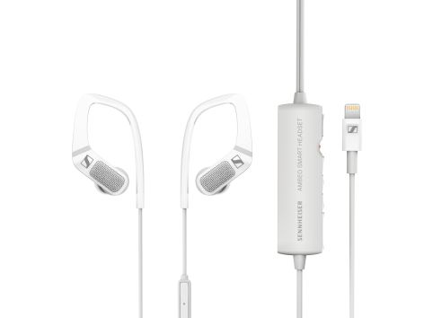 | The AMBEO SMART HEADSET is part of the toolkit that participants in the program will receive for developing augmented audio apps

A complete toolkit
All the creators selected will receive a free toolkit, comprising the hardware and software needed to develop augmented audio apps for iOS devices. On the hardware side, the kit includes the Sennheiser AMBEO SMART HEADSET for recording immersive binaural audio, sealing in-ear tips, and a headtracker. Software includes the AMBEO 3D binaural audio software library, the application programming interface for the AMBEO SMART HEADSET, and a fully functional demo project using Apple ARKit as an example.

Augmented audio experience at the Sennheiser booth
From March 11 to 14, the AMBEO team will provide a live demo of a typical augmented audio application at the Sennheiser booth (#908): Wearing the AMBEO SMART HEADSET and using an iPad, visitors are invited to watch a 30-minute live performance by funk-fusion goddess Noa of Playing Savage, whose solo vocals will be enhanced in real time by a full virtual backing band via an augmented reality app. Demos will take place at 11.30 a.m., 2 p.m. and 4 p.m.

Funk-fusion goddess Noa of Playing Savage (www.playingsavage.com) will perform at the Sennheiser booth (Photo credit: Severin Wurnig, photo editing: Leni Polar) | 

Additional SXSW activities
Sennheiser is also pleased to welcome its partner Dear Reality to the booth. Dear Reality will demo its VR/AR production software, Spatial Connect (https://youtu.be/ln61FNG3bB4) which enables a fully immersive workflow for VR/AR audio productions. This innovative tool eliminates the need for the audio engineer to switch back and forth between the production environment and the produced VR/AR content – the engineer can work in a fully immersive setting.

On Sunday, March 11, from 4:45 to 5:30 p.m., a panel discussion on “Augmented Reality and Sound” will take place in the German House. The panel will be hosted by Sebastian Gsuck, CEO of MediaApes, with the speaker line-up including Hartwig von Sass (CeBiT), Tom Ammermann (New Audio Technology), Daniel Guthor (CEO, Aspekteins), and Uwe Cremering (co-director AMBEO Immersive Audio, Sennheiser).

Visit Sennheiser at SXSW, Trade Show Area, Booth #908 from March 11 to 14.

Apple, iOS and iPad are trademarks of Apple Inc.

About Sennheiser
Sennheiser is shaping the future of audio – a vision built on more than 70 years of innovation culture, which is deeply rooted within the family-owned company. Founded in 1945, Sennheiser is one of the world’s leading manufacturers of headphones, microphones and wireless transmission systems. With 20 sales subsidiaries and long-established trading partners, the company is active in more than 50 countries and operates its own production facilities in Germany, Ireland and the USA. Sennheiser has around 2,800 employees around the world that share a passion for audio excellence. Since 2013, Sennheiser has been managed by Daniel Sennheiser and Dr. Andreas Sennheiser, the third generation of the family to run the company. In 2016, the Sennheiser Group had sales totaling €658.4 million. www.sennheiser.com

Local Contact Global Contact

Jeff Touzeau Stephanie Schmidt
jeff@hummingbirdmedia.com stephanie.schmidt@sennheiser.com
+1 (914) 602-2913 +49 (5130) 600 – 1275

